MR Worksheet

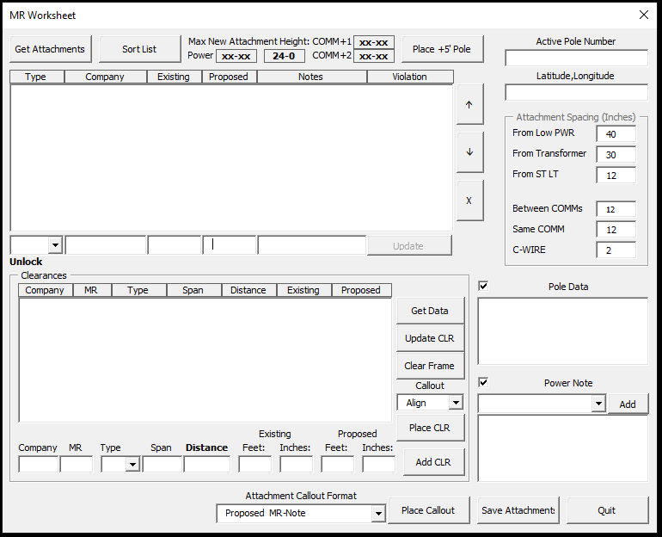

This program adds new attachments, moves existing attachments, and adds notes. Click Get Attachments to display the pole data and attachments in this form.

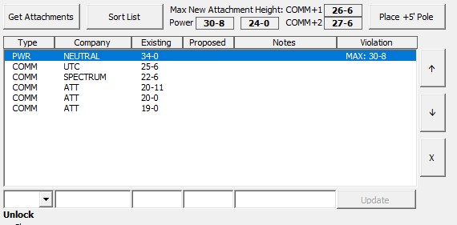

To add a new attachment to the pole, click one of the heights between Sort List and Place +5’ Pole buttons. They are the maximum height you can be without a power violation, 24’-0”, highest COMM + 1’, and highest COMM + 2’. Below shows all heights clicked.

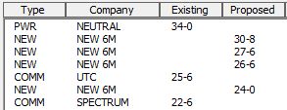

Note: if it is a power pole and there are more than 3 COMM and new attachments total, the program will add OCALC tot the Power Notes. If not needed, you will need to erase the text OCALC in the Power Note textbox.